SIMATS ENGINEERING
SAVEETHA INSTITUTE OF MEDICAL AND TECHNICAL SCIENCES
NAME: K. Hema sai Siddartha
DATE:15/10/2026
LAB EXP: 24
Reg Mo: 192325036
Course Code/ Name: DSA0602 / Data Handling and Visualization
Set 24 Product Inventory Management
Dataset: Product Inventory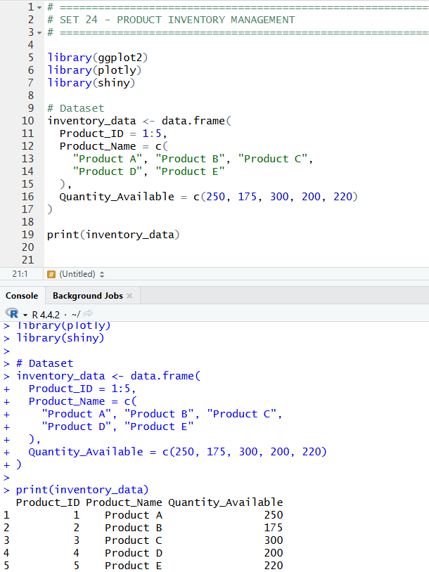
1.In R, create a bar chart to visualize the quantity of each product in the inventory. Label the axes and title the chart.
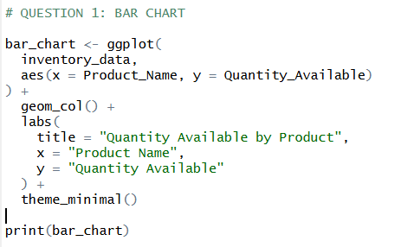
OUTPUT:
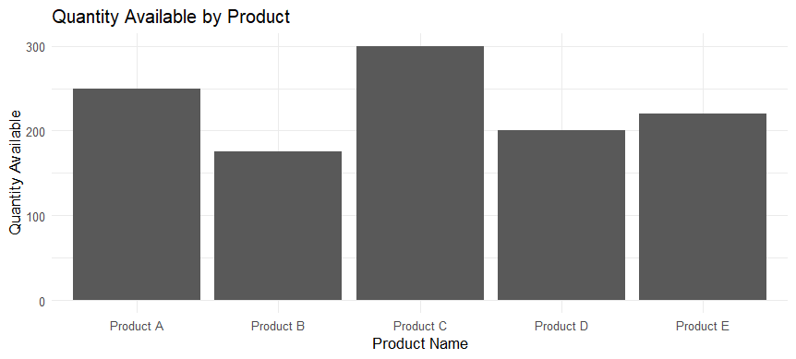

2.In R, generate a stacked bar chart to show the quantity of each product within different product categories.
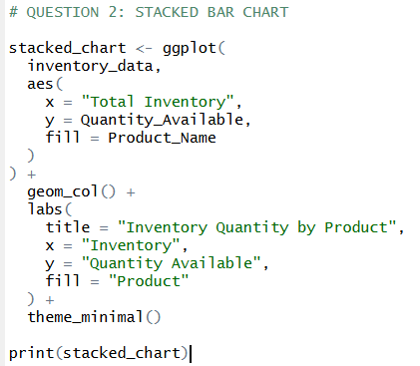
OUTPUT:
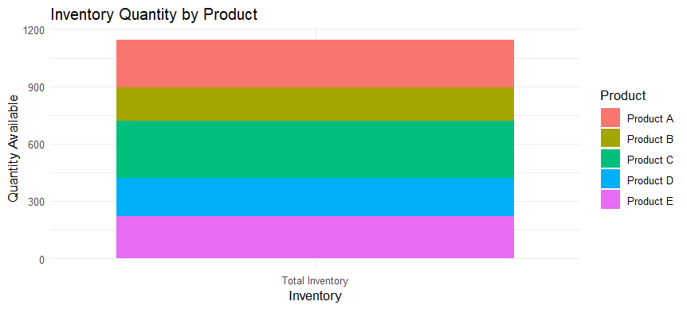

3.In Tableau, build a dashboard combining the bar chart and stacked bar chart for interactive exploration of inventory data.
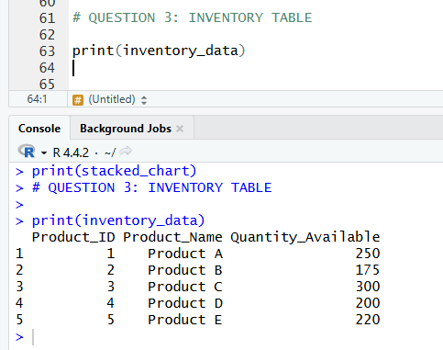

4. In R, create a scatter plot to explore the relationship between product price and quantity available. Explain any insights.
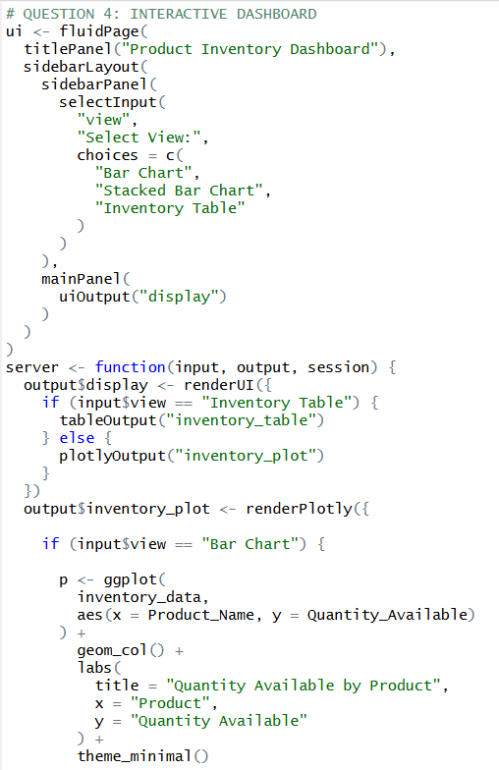
OUTPUT:
